Machine Learning and the Prediction of Over/Under Predictions in a College Football Game

When predicting outcomes in a college football game, one of the options is something called Over/Under. This is a number that oddsmakers release which is the predicted total of both teams’ score in a particular contest. For example, one game for which two high scoring teams are involved would see an over/under prediction of 80. When predicting the outcome of this type, one would either decide that the teams would score more (Over) or less (Under) than 80 points together.

One of the ways for which the author’s proprietary offensive and defensive ratings is to see if they can predict the Over/Under outcome of a particular game. This will be attempted using linear regression. In the third section assignment on statistics, linear regression was introduced by comparing the ratings to all of the teams points per game for the years 2010-2017. The results were regression lines for offense:

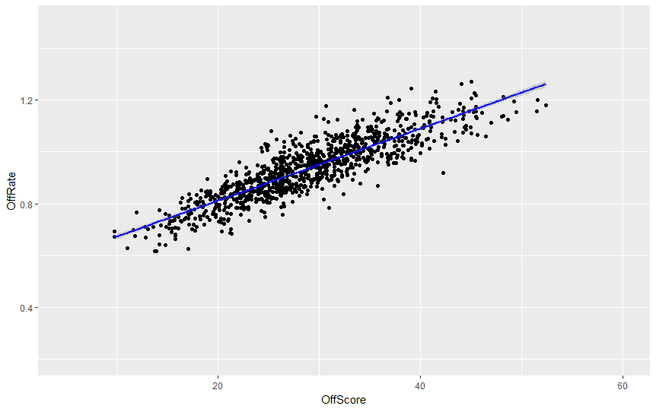

And Defense:

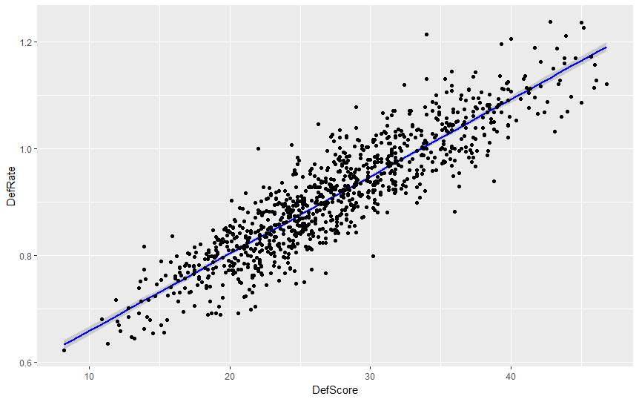

Since the equations for the regression lines are already known, for the exercise the two lines will be averaged and the subsequent equation (y=0.01415x + 0.5236) will be used to convert each of the ratings into a point total. The numbers for these outcomes (two for the home team and two for the away team), will then be added together and divided by two to come up with a predictor number which is then compared to the oddsmaker’s number. If the predictor number is greater than the oddsmaker’s number, the Over/Under prediction would be over and if it is less than the oddsmaker’s number, the prediction would be under.

The indication of success will be similar to the discussion on predicting game winners with the spread. The success rate of the predictive formula should be over 52.4%